EXP-8

**Capture Video/Audio from Webcam or Microphone and Display on Multimedia Interface**

# Aim:

To develop a program that captures:

* Live video from the webcam
* Live audio from the microphone and displays/records them using a simple multimedia interface.

# Procedure:

* 1. Use OpenCV for video capture from webcam.
  2. Use sounddevice and scipy or pyaudio for audio recording.
  3. Display the live webcam feed in a window.
  4. Optionally save the recorded video/audio to a file.
  5. Integrate into a basic Python GUI using tkinter.

# Code:

import cv2

import sounddevice as sd

from scipy.io.wavfile import write import threading

import tkinter as tk

# Audio recording function def record_audio():

duration = 5 # seconds

fs = 44100 # sampling rate print("Recording Audio...")

audio = sd.rec(int(duration * fs), samplerate=fs, channels=2)

sd.wait() # wait until recording is finished write('recorded_audio.wav', fs, audio)

print("Audio recording saved as 'recorded_audio.wav'.")

# Video capture function def capture_video():

cap = cv2.VideoCapture(0) if not cap.isOpened():

print("Error: Cannot access webcam.") return

print("Press 'q' to stop video.") while True:

ret, frame = cap.read() if not ret:

break

cv2.imshow('Webcam Feed', frame)

# Exit when 'q' is pressed

if cv2.waitKey(1) & 0xFF == ord('q'): break

cap.release() cv2.destroyAllWindows() print("Webcam closed.")

# GUI Setup window = tk.Tk()

window.title("Capture Audio and Video") window.geometry("300x200")

btn_audio = tk.Button( window,

text="•3! Record Audio",

command=lambda: threading.Thread(target=record_audio).start(), width=20,

height=2

)

btn_video = tk.Button( window,

text="◆ˆ.。•·ç Start Webcam",

command=lambda: threading.Thread(target=capture_video).start(), width=20,

height=2

)

btn_audio.pack(pady=20) btn_video.pack(pady=10)

window.mainloop()

# Output:

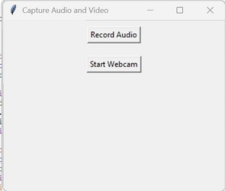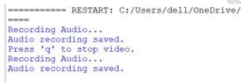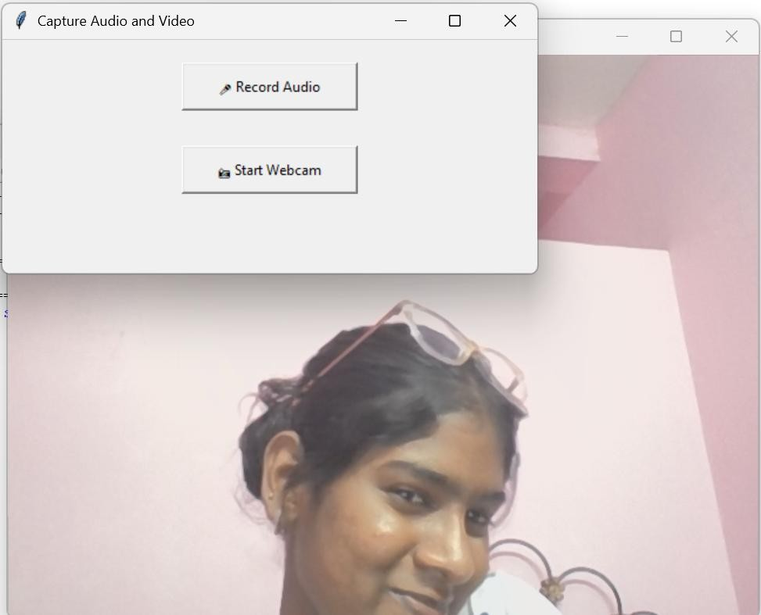

**Result:**

Live video and audio were successfully captured using webcam and microphone and displayed/saved through a multimedia interface.